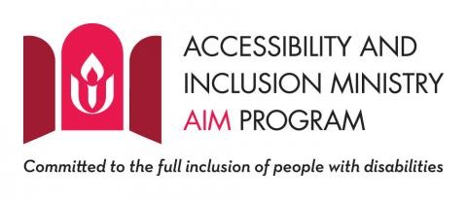
Our EqUUal Access group at the Unitarian Universalist Church of Tallahassee is currently in the process of becoming certified as an Accessibility and Inclusion Ministry congregation.

If you are making your first visit to the Unitarian Universalist Church of Tallahassee, please know that:

- There are four (4) parking spaces reserved for vehicles with a Disabled Parking Permit.

- A paved path with no steps leading to the sanctuary entrance.

- An automatic door opener on the primary entrance.

- A virtual sanctuary providing a live stream of the worship service for those who do not find the large sanctuary comfortable.

- ^{Accessible restrooms.}

- A large print hymnal and a Braille hymnal are available on request.

- A personal assisted listening device for people with a hearing loss is available on request.

If your child requires accommodations due to learning disabilities, or behavioral issues, or any other accessibility needs, please contact the Director of Religious Exploration in advance so the best possible arrangements can be made.

Greeters at the Sunday services can provide more information.

You are encouraged to contact the office administrator if you have additional requests for reasonable accommodation, or if you would like to have a tour of our facilities in advance.

The EqUUal Access group invites your participation in improving our access and inclusion. You are invited to join the group or give us your suggestions.

